**Unit 1.5 Graded Assignment**

**Name:** Mohammad Hamza Asim

**Employee #:** 2303.KHI.DEG.014

**Collaborated with:** Saad Sameer Khan (2303.KHI.DEG.034)

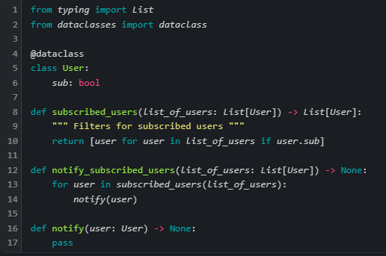

* Following the concept of **YAGNI**, we removed the 'import pandas' as we don't use pandas anywhere in our program. We also imported the Dataclasses module as it was missing.
* Next, we split the **'notify_users()'** function into two: **'subscribed_users()'** and **'notify_subscribed_users()'** so that each function does only ONE thing. We also gave them descriptive names.
* Finally, we put the **'notify()'** function (the callee) below the caller.